- Click on the folders on the task bar. 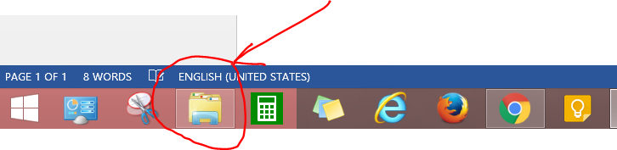
- Click on the printers icon. 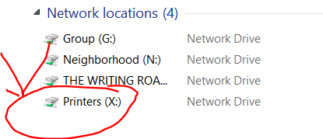
- Click on Sam Houston. 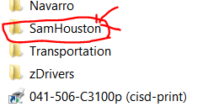
- Click on the printer. 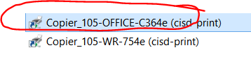
- Click on printer and select printer preferences.
- Click on basic. 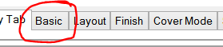
- Click on authentications. 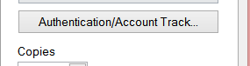
- Put in your user name and password. 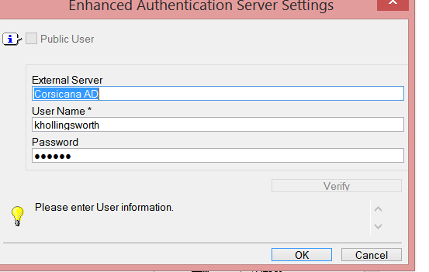
- Then click on Verify. 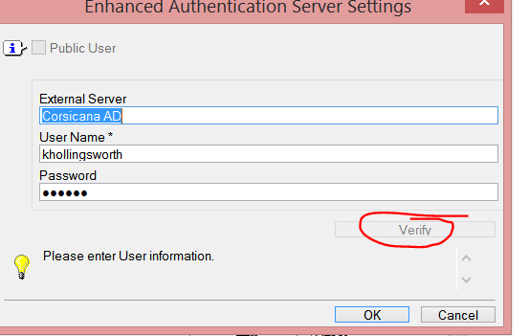
- You will get this message. Click on Ok and then Ok. 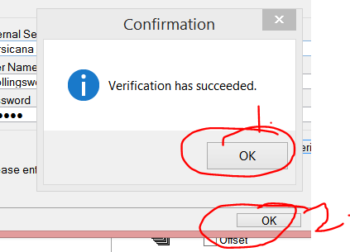
- Then you will get this page. Click on Apply 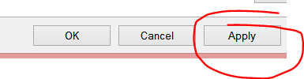
- Then click on OK. You will have to do this for both the office and the workroom.
- Make sure the workroom is your default printer.

